Getting Started with the  
Project Hawaii SDK

Version 2.1 – September 28, 2012

Abstract

Project Hawaii enables the development of mobile applications that access a set of cloud services and use Windows Azure™ for computation and data storage. This document describes how to install the Project Hawaii software development kit (SDK), lists the prerequisites for using the SDK, and lists the sample applications that are part of the installation.

Contents

Introduction 2

Hardware and Software Requirements 2

System and Hardware 2

Software 3

How to Install and Build the Project Hawaii SDK 3

Project Hawaii Authentication Credentials 4

Obtaining a Hawaii Application ID 4

Obtaining Azure Data Market Credentials 5

Configuring Your Credentials 6

Sample Applications 7

Resources 7

**Disclaimer:** This document is provided “as-is”. Information and views expressed in this document, including URL and other Internet Web site references, may change without notice. You bear the risk of using it.

This document does not provide you with any legal rights to any intellectual property in any Microsoft product. You may copy and use this document for your internal, reference purposes.

© 2012 Microsoft Corporation. All rights reserved.

DirectX, Microsoft, Visual Studio, Silverlight, Windows Azure, and Windows are trademarks of the Microsoft group of companies. All other trademarks are property of their respective owners.

# Introduction

Project Hawaii supports the development of mobile applications that access a set of cloud services and use Windows Azure™—Microsoft's cloud services platform—for computation and data storage. Project Hawaii participants have access to Windows Azure for use in creating their own cloud services.

The Project Hawaii Software Development Kit (SDK) enables you to create mobile applications that take advantage of research cloud services. The Project Hawaii SDK includes the following services:

* The Key-Value service enables a mobile application to store application-wide state information in the cloud.
* The Optical Character Recognition (OCR) Service returns the text that appears in a photographic image. For example, given an image of a road sign, the service returns the text of the sign.
* The Path Prediction Service predicts a destination based on a sequence of current locations and historical data.
* The Relay Service provides a relay point in the cloud that mobile applications can use to communicate.
* The Rendezvous Service maps from well-known human-readable names to endpoints in the Hawaii Relay Service.
* The Smash Service provides a general sharing mechanism for observable collections, so that applications can easily create social computing scenarios.
* The Speech-to-Text Service takes a spoken phrase and returns text. Currently this service supports English only.
* The Translator service enables a mobile application to translate text from one language to another, and to obtain an audio stream that renders a string in a spoken language.

# Hardware and Software Requirements

This section describes the hardware and software requirements for using the Project Hawaii SDK.

## System and Hardware

The Project Hawaii SDK requires the same system hardware and software as the Windows Phone SDK 7.1:

* Windows 7 or Windows Vista with Service Pack 2, either 32-bit or 64-bit version (all editions except starter editions)
* At least 4 GB of free disk space on the system volume
* 3 GB RAM

If you plan to run Windows Phone Emulator, your system must also have the following:

* A graphics card that supports Microsoft DirectX® 10 or DirectX 11 and has a Windows Display Driver Model (WDDM) 1.1 driver and Microsoft Direct3D Version 10 DDI or later version.
* Support for GPU emulation, if you plan to enable profiling, run XNA Framework applications, or display content in web browser controls.

## Software

The Project Hawaii SDK requires the following software on your system:

* Windows Phone SDK 7.1, available at  
  <http://www.microsoft.com/download/en/details.aspx?id=27570>
* Microsoft Visual Studio® 2010 Express edition or Visual Studio 2010 Professional. Visual Studio 2010 Express Edition is provided with Windows Phone SDK 7.1.

The following software is not required, but you might find it helpful for developing mobile applications for Windows Phone:

* Silverlight® for Windows Phone Toolkit. This Toolkit provides additional controls for application development. You can download this toolkit from <http://silverlight.codeplex.com/releases/view/55034>.
* Windows Azure Toolkit for Windows Phone. The Toolkit includes class libraries, Visual Studio project templates, documentation, and sample applications that are designed to make it easier to build Windows Phone applications. You can download the toolkit from the following location:  
  <http://watwp.codeplex.com/>

To use the Project Hawaii SDK, you should be familiar with the following:

* Software development in C# using Visual Studio and Windows Communication Foundation (WCF).
* Application development for mobile platforms such as Windows Phone 7.

# How to Install and Build the Project Hawaii SDK

Before you can install the Project Hawaii SDK, you must uninstall any previous versions.

To uninstall a previous version

1. Open **Control Panel** and click **Uninstall a program**.

2. In the list of programs, click “Cloud Services SDK for WP7 1.0.8” or “Microsoft Research Project Hawaii SDK 2.0.”

3. Click **Uninstall**.

To install the Project Hawaii SDK

1. Download the Project Hawaii SDK from the link on the following page and save it on your disk:  
<http://research.microsoft.com/en-us/projects/hawaii/default.aspx>

2. Run HawaiiSDKSetup.msi to start the installation procedure.

3. By default, the installation procedure installs the SDK in the following folder and makes it available only to you:

* Documents\Microsoft Research\Project Hawaii SDK 2.1

To install the software in a different location, or to make it available to anyone who uses the computer, change the default in the **Select Installation Folder** dialog box during installation.

The installation procedure creates a shortcut on the **Start** menu to **Microsoft Research Project Hawaii SDK 2.1**.

The Project Hawaii SDK installation includes the following folders:

|  |  |
| --- | --- |
| Name | Description |
| Documentation | Reference, programming, and installation documentation for the libraries and services. |
| Source | Source code for the client libraries and sample programs. |

The Source folder contains source code for the client libraries that the sample programs use to communicate with the Project Hawaii services. You must build the SDK before you can build individual sample programs.

To build the Hawaii SDK

1. Click **Project Hawaii SDK 2.1 Solution.sln** on the **Microsoft Research Project Hawaii SDK 2.1** item on the **Start** menu.

2. Build the solution.

Although the solution file builds the sample applications, you must supply a Hawaii Application ID before you can use them, as described in the next section.

# Project Hawaii Authentication Credentials

Each application that uses a Project Hawaii service must authenticate itself with the service by using either a Hawaii Application ID or Azure Data Market (ADM) client ID and secret.

Currently, the OCR and STT services require a Hawaii ID; they do not accept ADM credentials.

## Obtaining a Hawaii Application ID

You must have a Windows Live ID to obtain a Hawaii Application ID. If you do not have a Windows Live ID, see “How do I sign up for Windows Live” at <http://windows.microsoft.com/en-US/windows-live/sign-up-create-account-how>.

To obtain a Hawaii Application ID

1. Go to the **Project Hawaii Signup** web page at <http://hawaiiguidgen.cloudapp.net/default.aspx>.

2 Sign in with your Windows Live ID.

3. If you have not yet registered your Live ID, the Project Hawaii Signup page displays a dialog box like the following. Click **Register this Live ID with Hawaii** to register your ID.

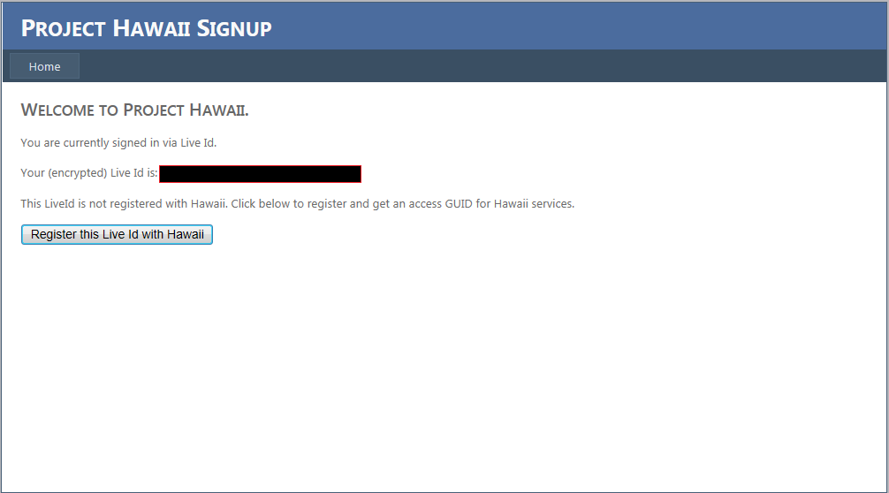

4. When you register your Live ID, Project Hawaii generates a GUID that your application can use to authenticate with the Project Hawaii cloud services.

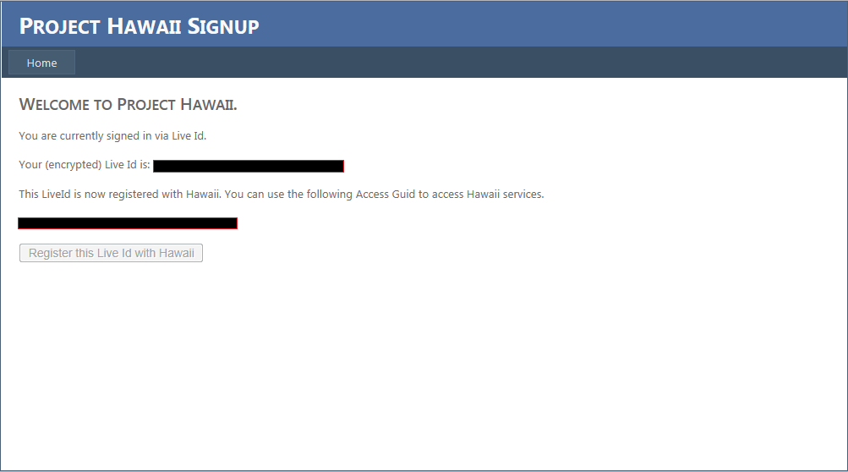

**Important** Make a note of the Access GUID so that you can copy and paste it into your code.

The sample applications that are installed with the Project Hawaii SDK show how to use the Hawaii Application ID for authentication.

## Obtaining Azure Data Market Credentials

You must have a Windows Live ID to obtain ADM credentials. If you do not have a Windows Live ID, see “How do I sign up for Windows Live” at <http://windows.microsoft.com/en-US/windows-live/sign-up-create-account-how>.

To obtain an ADM clientID and secret

1. Go to the Windows Azure Marketplace web page at [https://datamarket.azure.com](https://datamarket.azure.com/).

2. Use your Windows Live ID to sign in and register for ADM.

3. Click the **Developers** link at the bottom of the page to navigate to https://datamarket.azure.com/developer/applications.

4. Click **Register** to create an application that accesses the Project Hawaii Service.

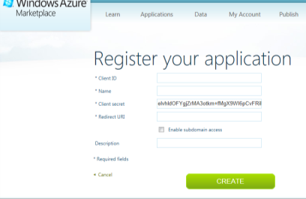

5. On the **Register your application** page, enter the required information:

* The Client ID. This can be any string you choose, but it must be unique and it cannot be changed later. For example, Contoso.MyAppV1.0.
* The name of your application.
* The post-consent redirect URI.
* A description for your application.

**Important** Make a note of the ClientID and Client secret so that you can copy and paste them into your code.

6. Navigate to the following web page and subscribe to the offer:  
<https://datamarket.azure.com/dataset/486345cb-b88f-4e4e-b8c7-5b5cf75cb830>

The sample applications that are installed with the Project Hawaii SDK show how to use the ADM credentials for authentication.

## Configuring Your Credentials

Most sample applications include the HawaiiClient.cs file, which defines the **HawaiiClient** class. This class is used as a container for either the **HawaiiApplicationID** string or the **AdmClientId** and **AdmClientSecret** strings. The strings are empty when you install the samples, as the following shows:

public static class HawaiiClient

{

public const string AdmClientId = "";

public const string AdmClientSecret = "";

}

To use a sample, insert your credentials into the strings. When the application calls a service, it passes the credentials as parameters so that the service can authenticate the request. You can use a similar mechanism in your own code.

# Sample Applications

The Project Hawaii SDK includes the following sample applications:

|  |  |
| --- | --- |
| Sample | Decription |
| KeyValueSample | Uses the Key-Value service to create, search for, and delete key-value pairs. |
| OcrSample | Uses the OCR service to return the text that appears in a photo stream or file. |
| OcrSampleLite | Uses the OCR service to return the text that appears in a photo stream. |
| PathPredictionSample | Uses the Path Prediction service to predict the user’s destination based on current location data. |
| RelaySample | Uses the Relay service to create and group endpoints and to send and receive messages. |
| RelayPivotSample | Provides the same features as RelaySample in a Windows Phone pivot application. |
| RendezvousSample | Uses the Rendezvous service to create friendly names and associate them with registration IDs created by the Relay service. |
| SmashSampleApp | Uses the Smash service to share data. |
| SmashSampleAppDesktop | Uses the Smash service to share data and manage Smash sessions. |
| SpeechToTextSample | Enables a user to record speech and then send it to the STT service for translation to text. |
| TranslatorSample | Uses the Translator service to translate typed text from one language to another and to speak text in your choice of languages |

# Resources

This section provides links to additional information about the Project Hawaii SDK and Windows Phone 7 application development.

Microsoft Research Project Hawaii

<http://research.microsoft.com/en-us/projects/hawaii/default.aspx>

Microsoft Research Project Hawaii on Facebook

<http://www.facebook.com/pages/Microsoft-Research-Project-Hawaii/164295863611699>

MSDN

Programming Windows Phone 7  
<http://blogs.msdn.com/b/microsoft_press/archive/2010/10/28/free-ebook-programming-windows-phone-7-by-charles-petzold.aspx>

How to: Create Your First Silverlight Application for Windows Phone  
<http://msdn.microsoft.com/library/ff402526(v=VS.92).aspx>

How to: Create Your First XNA Framework Application for Windows Phone  
<http://msdn.microsoft.com/en-us/library/ff472340(v=vs.92).aspx>

Windows Azure Marketplace Developer Information

<https://datamarket.azure.com/developer/applications>